CAB230 – WEB COMPUTING

Assignment 2

Student 1: n9506420 Ian Maskell

Student 2: Cameron Short

Preferred Application: Chrome

**Home Screen Testing – Part A**

**Part E – Adding a Review**

When a user is in the item page they have the option to post a review if they are logged in. If they are not logged in then the Add Review button is disabled and selecting it will show a prompt explaining that the user must log in. An example is shown below.

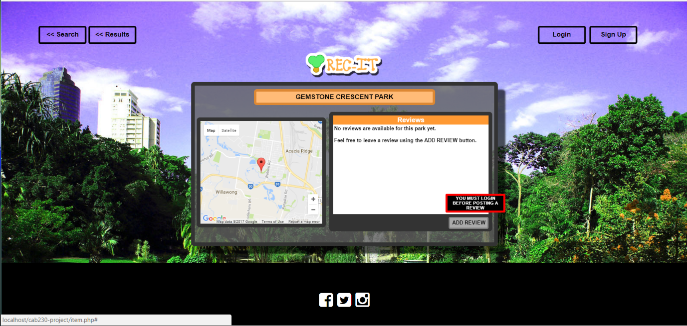

However when a user selects the ADD review button when logged in a fixed overlay is displayed which is used to add a review. As shown below.

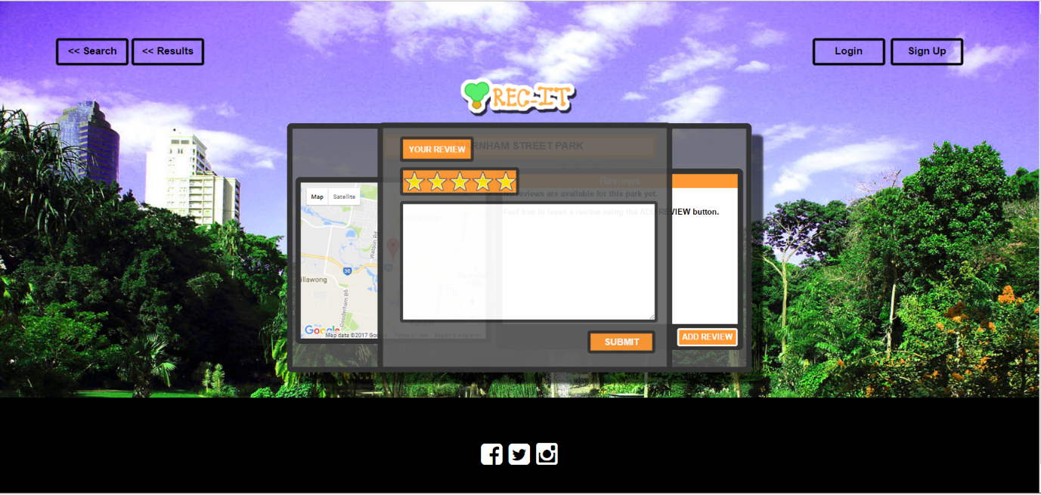

The post review overlay only has two components the user can select for their review, the star rating (which by default is 5), and the text field. The text field must be over 20 words, this is to prevent empty reviews. An example is shown below.

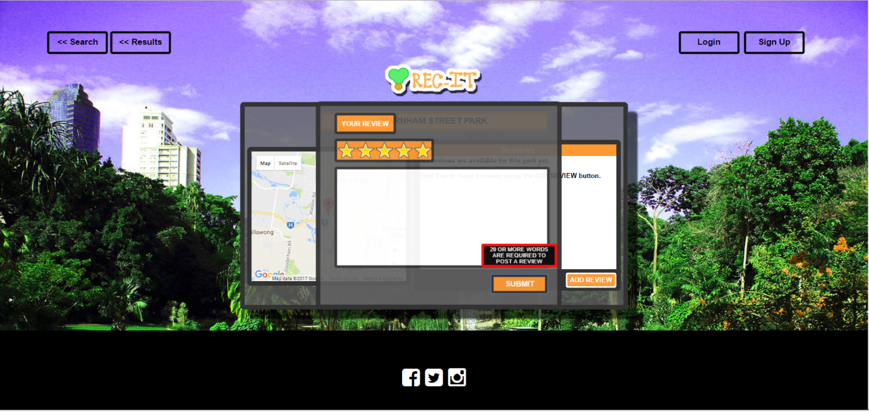

When the post complies with the requirement the page is directed to a page that confirms that the post has succeeded. After 2 seconds the page returns back to the item page the user was originally viewing with the included review.

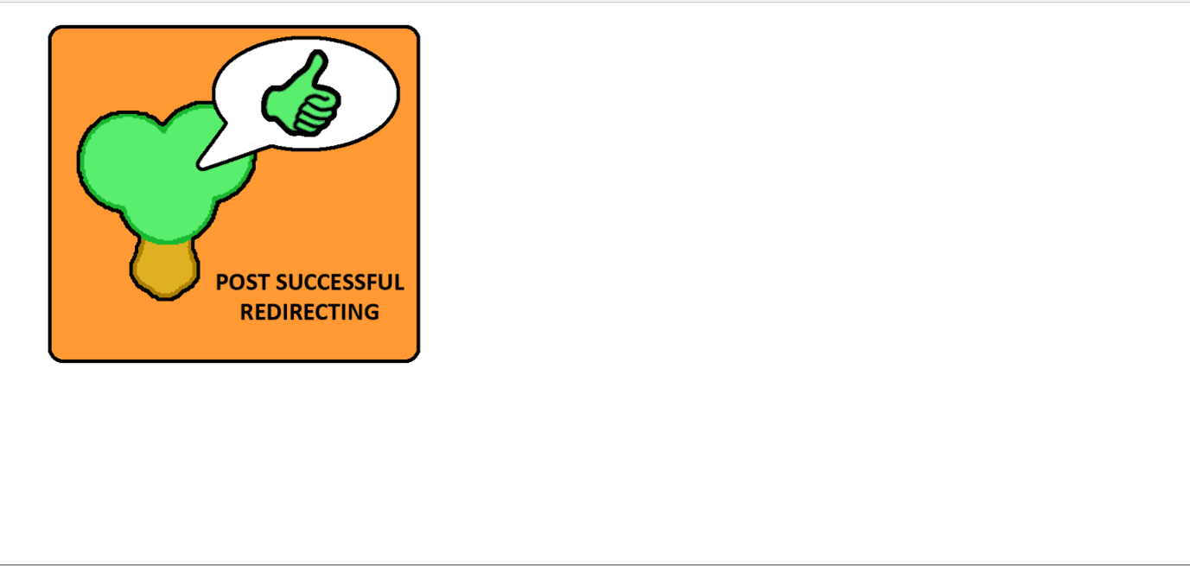

**F – Searching for an item that exists in the database**

The only input that needs validation on the Search (Home) page is the text input by the user in the search box. When the page loads two arrays are created in JS from information retrieved from PHP via SQL query. A HTML datalist element is created from the two arrays. After 3 characters are entered remaining possible matches will display in a dropdown box. As shown below.

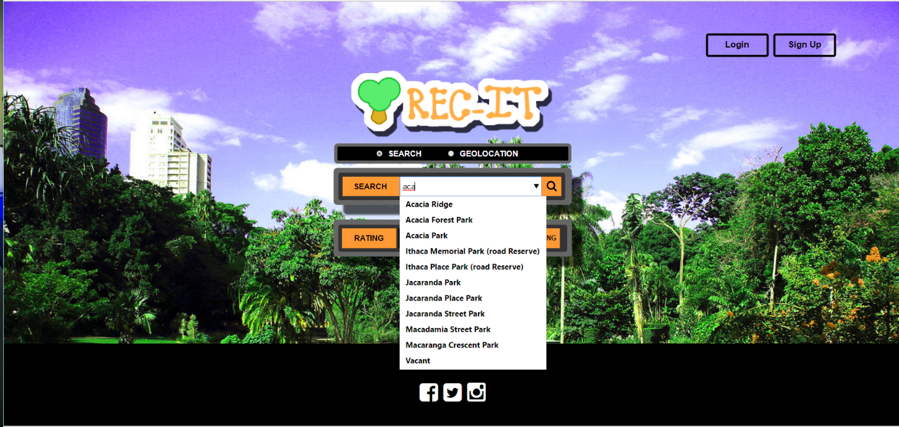

If the user was to select Acacia Ridge they are directed to the results page with results that match the suburb. As shown below.

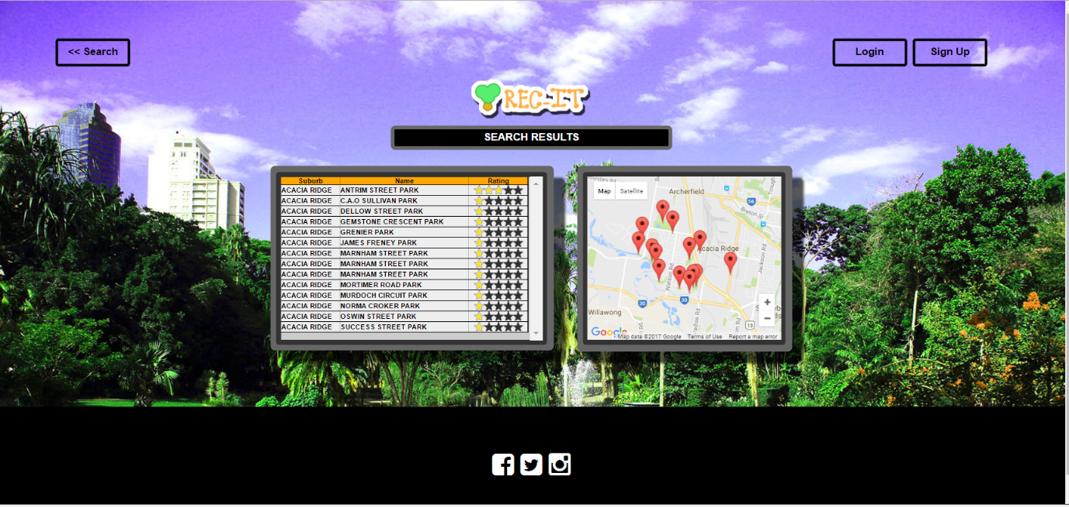

**G. Searching for an item that does not exist in the database**

Any input that does not match a datalist entry receives an Invalid search location in the search input bar and they are unable to continue until a valid Suburb or Park Name is entered. In the example below a user puts in a query that does not match any existing suburb or parkname.

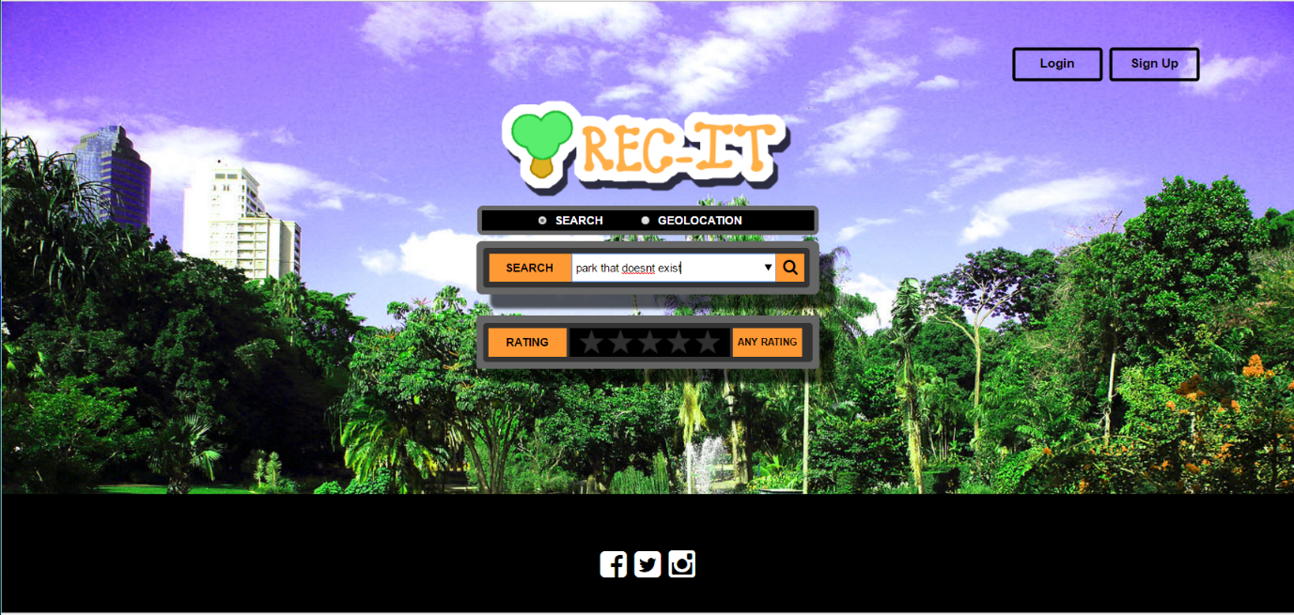

The search input box alerts the user to the issue.

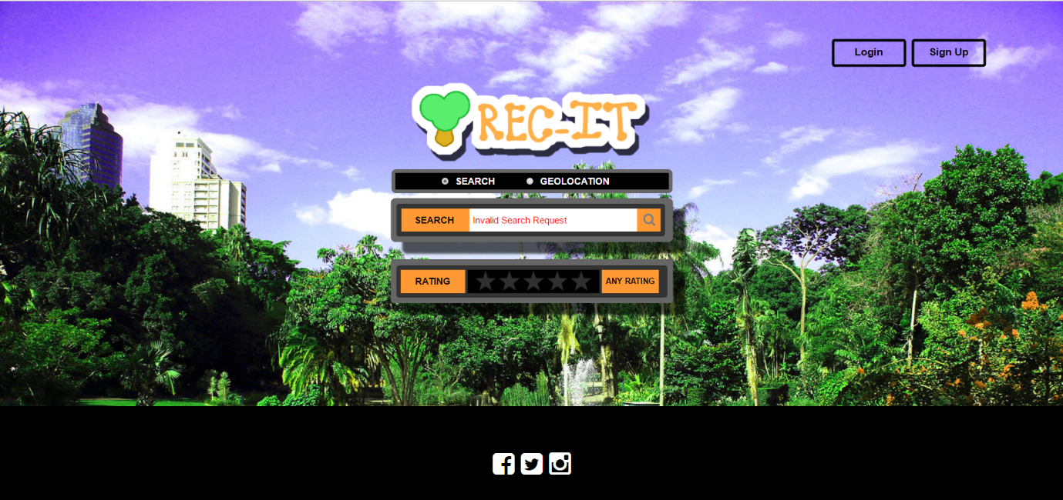

**H. Individual Search Item Page**

From the results page the user can select either the park map pin (which displays the name of each park when hovered) or the park from the list of results. In the test below the user selects ‘Antrim Street Park’.

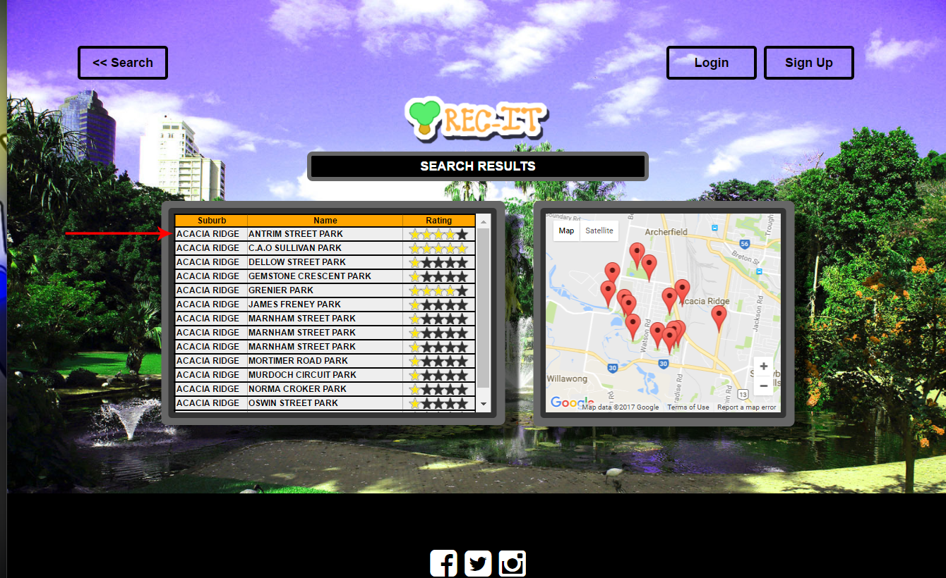

From here the item page for the selected park is displayed. A map with the individual park location is displayed on the left and the reviews on the right. It also allows the user to write their own review when logged in.

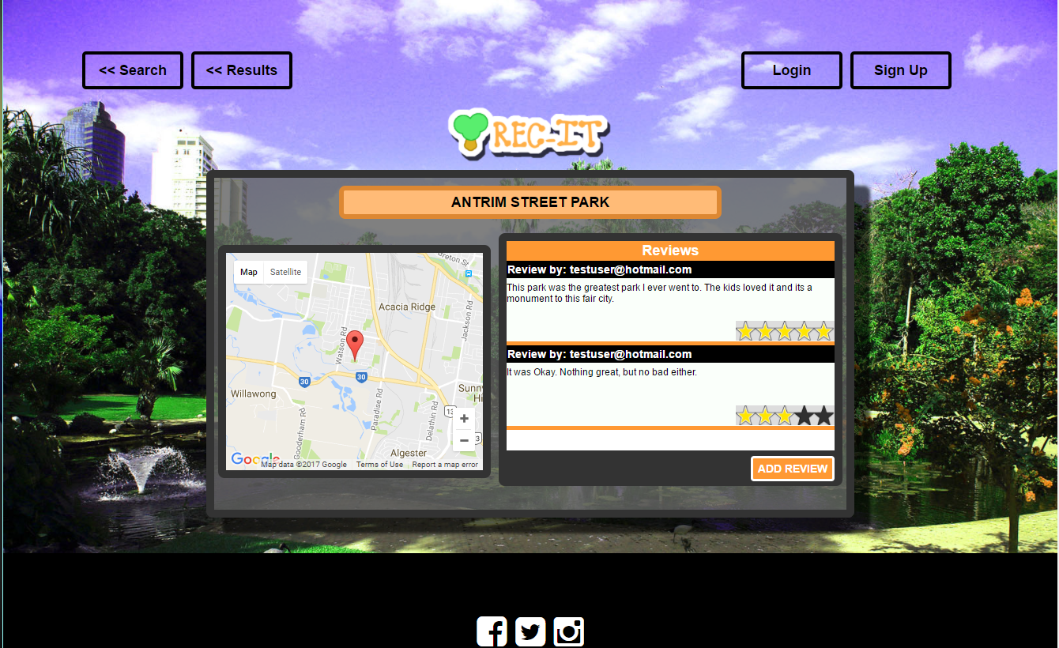

**I. Attempting to Use a cross site scripting attack but not being successful**

In the search page html I injected a script to show an alert to display the document cookies.

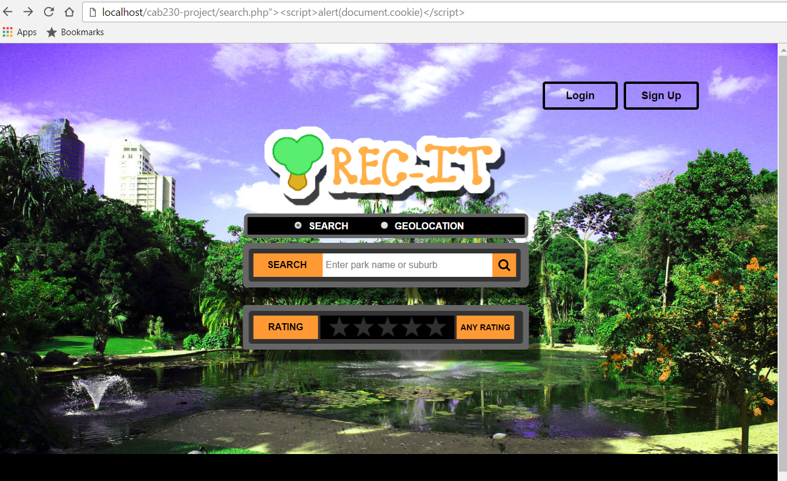

The result is blocked by the server as the user doesn’t have permission to access html with the injected code.

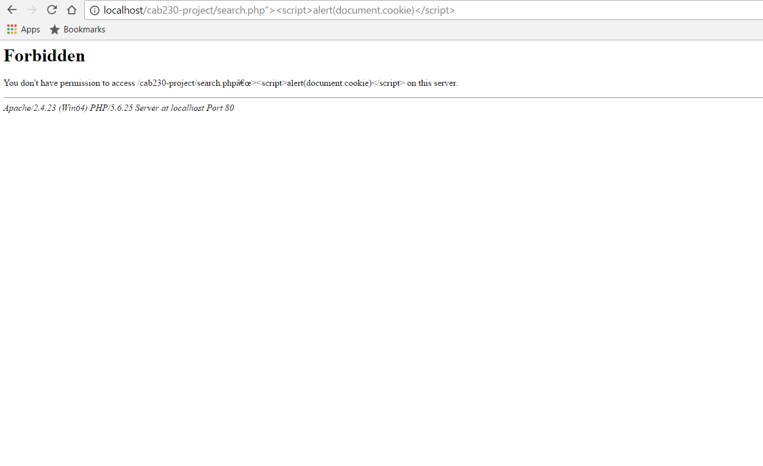

**J. Attempting to Use an SQL injection attack but not being successful**

**K. Unregistered User Not Being able to Log In**

**L. Operating gracefully in multiple resolutions**

The majority of sizes are effected by the window width, whereas the window height wont affect the elements. If elements are outside the height of the screen the scrollbar allows them to navigate up and down. If the width is adjusted the elements adjust with it (to a minimum of 1024px).

The first screen below shows the screen just slightly above the minimum width. There is no width scroll, however there are elements of the page outside the vertical view, so there is a scroll bar to navigate up and down.

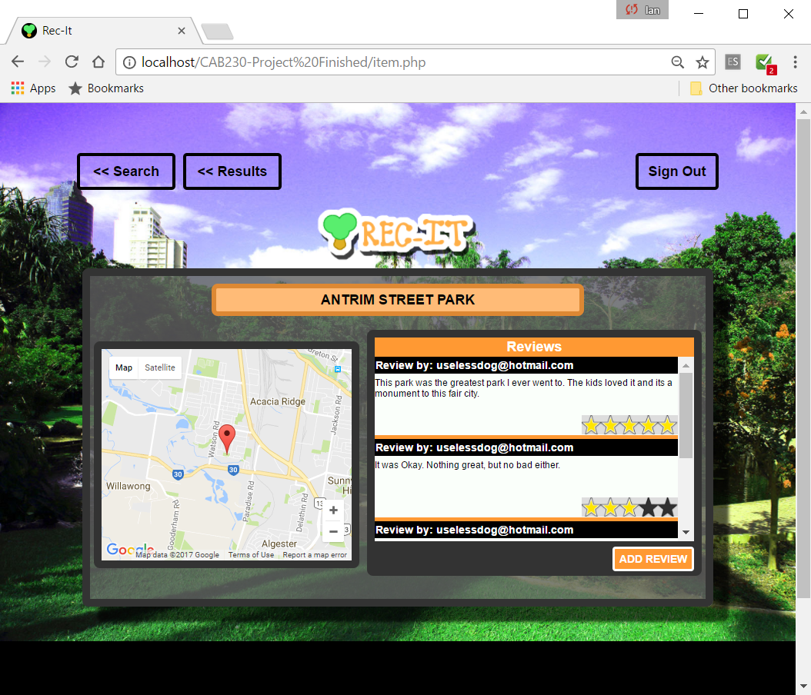

The second screen is an expanded screen (roughly 1900 width, Zoom 75%). It shows that elements have moved and the background has expanded with the screen.

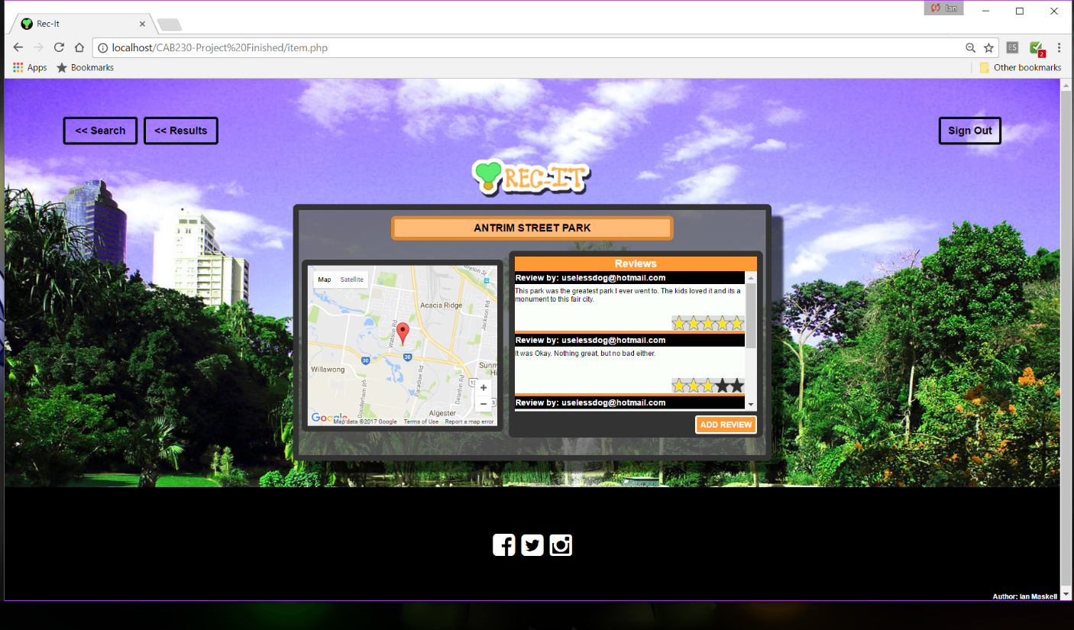

The third screen shows a screen under the minimum width. It shows that the elements stopped being affected by the width and the horizontal bar that appears.

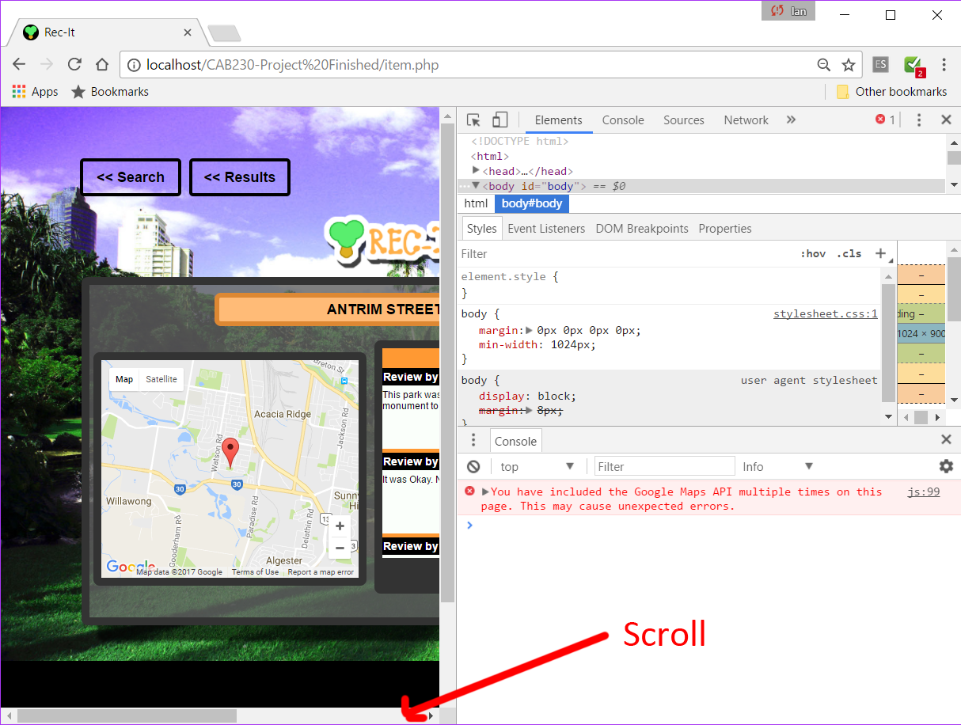

**M. SQL Example Query**

The below query is used to get the row for the park selected in the ‘park’ column located in the SQL database. It is located in the functions.inc file. The ‘sqlGetPark’ function is a function within the ‘itemPage’ function which is the function called when the item page is loaded. This function is responsible for retrieving information about the page a user wishes to view, then php populates that information for use in the browser.

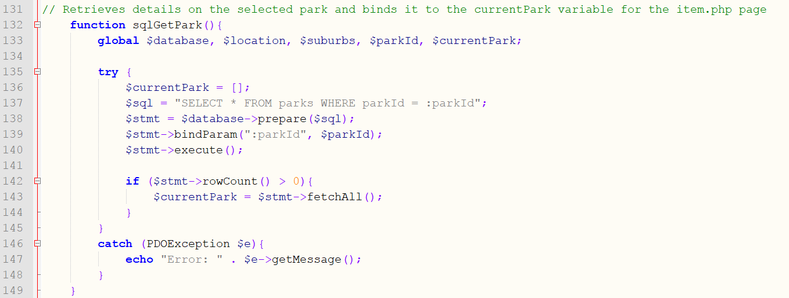

**N/O. Results and Item Page Maps**

The first screenshot is of a search for the suburb ‘Acacia Ridge’. The map displayed contains all the positions retaining to the search queries as markers. The markers allow a user to continue to the individual items page of the park it represents. When the user hovers over the markers the name of the park is displayed in a small info box.

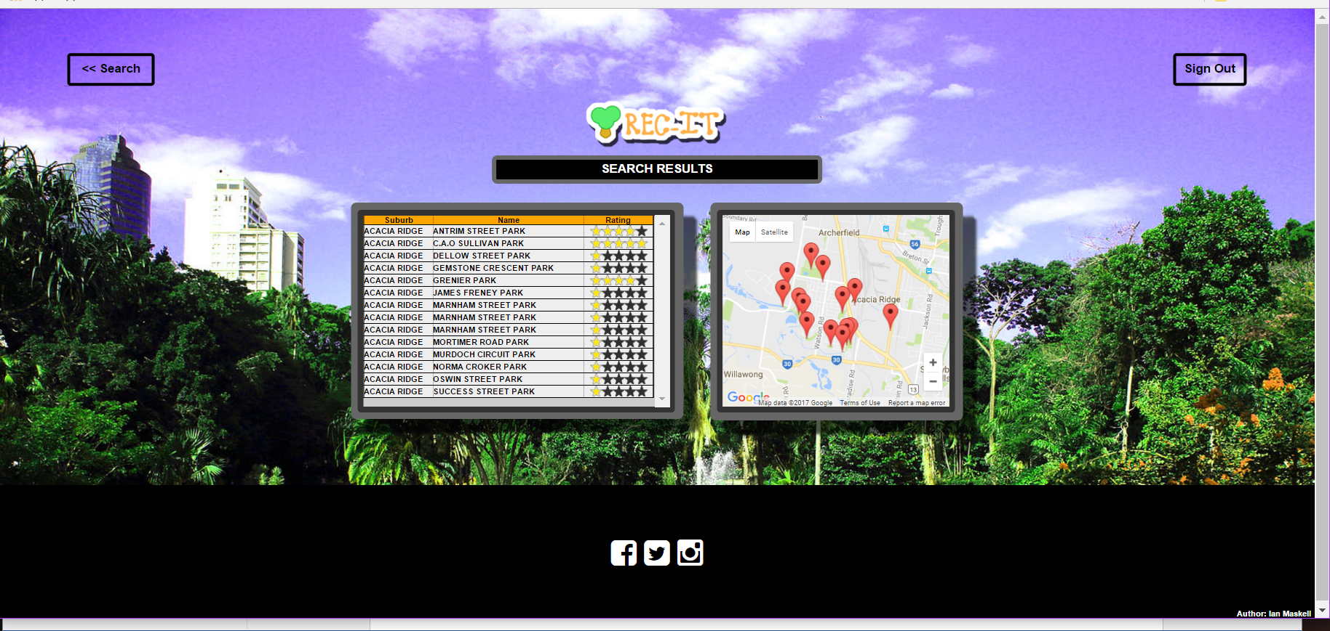

In the second screenshot the user has selected the Antrim Street Park marker. It displays the items page with the relevant park information and reviews. It also has a map showing a marker for the individual park selected. Although this marker still displays the park name it does not redirect the user as they are already on the relevant item page.

**P. GeoGraphic Microdata is valid**

**Q. Evidence review microdata is valid**

The first image is of the source code for the item page that was put into the Google data validator.

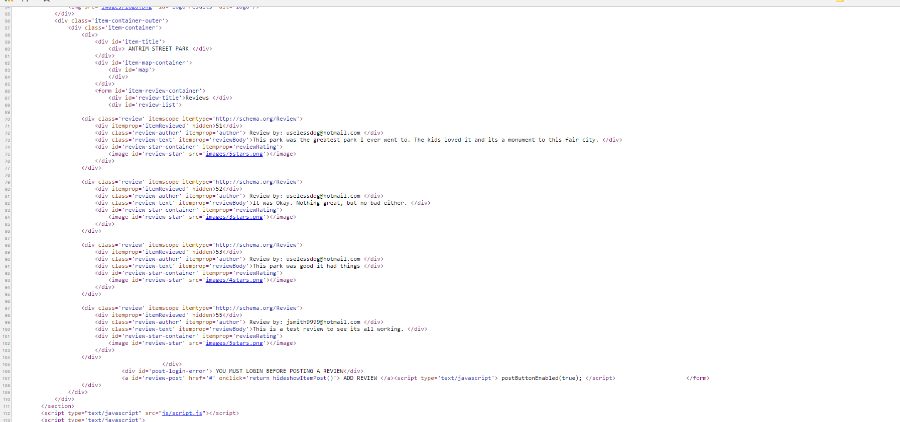

The result was 4 Reviews which have the microdata of what was reviewed.

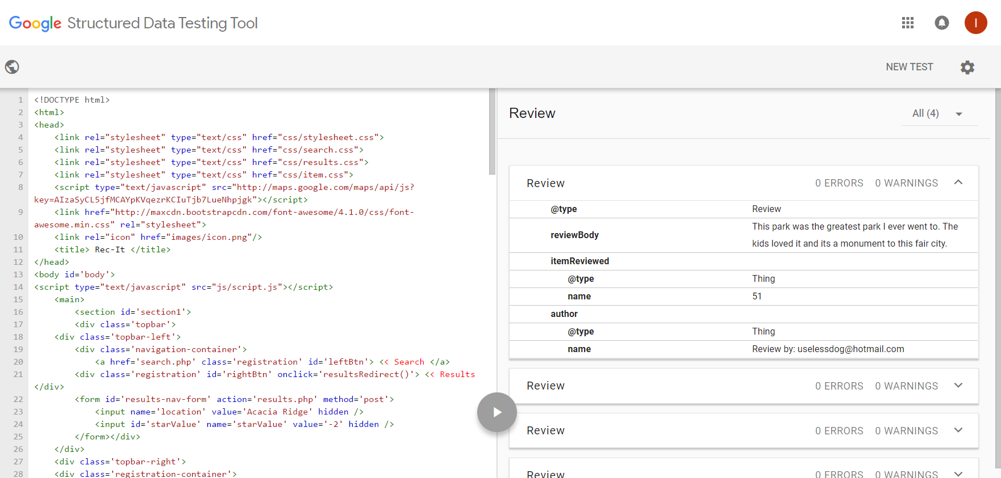

**WEB DESIGN PRINCIPALS REPORT**

**User Experience –** The website is very simple to navigate and for users to lookup information on the parks they search for. A user is able to do a search and display results of that search with minimal input. The site is also very google like when I comes to making a query, so they would already understand how the site is working.

The results page gives the user the option to select the park they want from both a list or from the map. However the results page blocks the map and results in separate containers so it’s easy to decide how they want to search.

The individual item page blocks relevant information together. It has the parks name as the heading, the map section on the left to view where the park is, and also the right box houses the review information. When the user want to create a review, a fixed element is displayed over the page. To close the review post they just need to click outside the box which is simple and is a function most users understand.

**Visual Design –** Firstly all the pages have adequate amounts of whitespace between elements so the user isn’t bombarded with too much information. The page uses a consistent colour scheme of oranges, greens, blacks and whites throughout all pages. The fonts are to a good size, font style, and colour contrast so that it is easily legible. Elements with potentially long spans i.e. the reviews section, are scrollable rather than having elements that make the page go constantly longer.

The design of the pages isn’t compromised in other browsers, or changing screen resolutions. Elements on the page aren’t typically large in size which allow people with slow connections to access pages.

**Page Layout –** The page layout is simple and presented in a way that draws the user to the centre of the page. Elements are presented in blocks down the page and provide a good amount of whitespace. All pages are also flexable to the width, and becoming scrollable when under 1024px wide. This means elements move and expand to the page over 1024px wide, but won’t become too small when the screen gets too small.

**Standards -**